**UNIT – 1 BASICS OF ROBOTICS**

**Introduction :**

Robotics is an interdisciplinary branch of computer science and engineering. Robotics involves the design, construction, operation, and use of robots. The goal of robotics is to design machines that can help and assist humans.

**Basic Components of wrist configuration :**

Motion –Motion planning is a term used in robotics for the process of breaking down a desired movement task into discrete motions that satisfy movement constraints and possibly optimize some aspect of the movement. For example, consider a mobile robot navigating inside a building to a distant waypoint.

Roll- This is also called wrist swivel, this involves rotation of the wrist mechanism about the arm axis.

Pitch- It involves up & down rotation of the wrist. This is also called as wrist bend.

Yaw- It involves right or left rotation of the wrist.

Sensors – Robotic sensors are used to estimate a robot’s condition and environment. These signals are passed to a controller to enable appropriate behavior. Sensors in robots are based on the functions of human sensory organs. Robots require extensive information about their environment in order to function effectively.

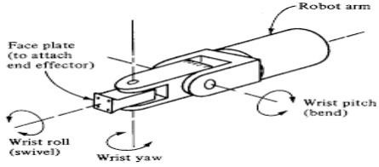

**Laws of Robotics :**

1. a robot may not injure a human being or, through inaction, allow a human being to come to harm.
2. a robot must obey the orders given it by human beings except where such orders would conflict with the First Law.
3. a robot must protect its own existence as long as such protection does.

**Classification of Robot :**

* + Autonomous mobile robots (AMRs)
  + Automated guided vehicles (AGVs)
  + Articulated robots, #Humanoids,
  + Cobots,
  + Hybrids.

Robots are used to drive efficiency, expedite processes, improve safety, and enhance experiences across many industries.

**Workspace :**

A robotic’s workspace is the space in which the robot operates on the production line or in a workcell. Each industrial articulated robot has a very specific workspace for which it can operate and move around within. It is important to discuss your specific needs to find the best automated fit for your production line.

**Accuracy :**

Accuracy is the ability of a robot to move its end effector to a desired position and orientation that has never been attained before.

**Resolution and Repeatability of Robots :**

Resolution is defined as the smallest incremental move that the robot can physically produce.

Repeatability is a measure of the ability of the robot to move back to the same position and orientation over and over again.

**POWER TRANSMISSION SYSTEM :**

Power transmission systems power your electronic devices and are made up of one or more, synchronized actuators that turn input energy into output movement to complete tasks. An actuator is a component of a machine that is responsible for moving and controlling a mechanism or system **Rotary to Linear Motion :**

Rotation can be converted into linear motion via a screw-and-nut system assembled on the motor shaft. There are two main types of screw-and-nut systems: ball screw and lead screw. A ball screw operates on rolling contact between the nut and a screw. The ball is recirculated along a helical groove.

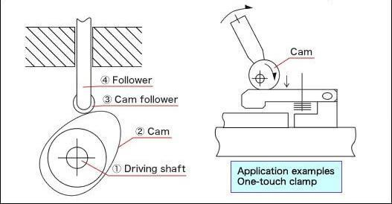

**Power transmission system in drives :**

1. Harmonics Drives:

Harmonic Drive, also called Harmonic Drive gear, harmonic gear, or strain wave gearing, mechanical speedchanging device, invented in the 1950s, that reduces the gear ratio of a rotary machine to increase torque. It operates on a principle different from that of conventional speed changers.

1. Gear Drives:

Gear drives are complex mechanical systems which are used in nearly all types of machinery, such as robots, aircraft and automobile. The design of a gear drive is a tedious and time-consuming process that depends largely on the experiences and intuitions of the designer.

1. Belt Drives : Belt drives provide freedom to position the motor relative to the load and this phenomenon enables reduction of the robot arm inertia. It also facilitates quick response when employed in robotics. Unfortunately, the flexible dynamics deteriorates the positioning accuracy.

**Configurations of Robots :**

The configuration space is a transformation from the physical space in which the robot is of finite-size into another space in which the robot is treated as a point.

There are six major types of robot configurations;

* 1. Cartesian -A Cartesian coordinate robot is an industrial robot whose three principal axes of control are linear and are at right angles to each other. I) Ex : Single axis robots,

Linear motor single axis robots.

II) Applications :Examples of use with single axis and additional axis and using long stroke dual drive.

* 1. Cylindrical - The robots have a cylindrical-shaped work envelop, which is achieved with rotating shaft and an extendable arm that moves in a vertical and sliding motion.
     1. Ex : Spot welding automation ,Robotic casting and molding machine handling.
     2. Applications : General machine handling applications,Material handling applications including package assembly and palletizing.
  2. Spherical – A Spherical Robot, also known as spherical mobile robot, or ball-shaped robot is a mobile robot with spherical external shape.
     1. Ex : Fettling machines, Diecasting
     2. Applications : Used for the fabrication, finishing, transfer and assembly of parts

1. Selective Compliance Articulated Robot Arm (SCARA). Articulate – Improve the speed and repeatability ON PICK&PLACE TASKS from one location to another or to speed and improve the steps involved in assembly.I) Ex : Robot with vision processing function.

Electric gripper**.**

II)Applications : Allows a workpiece to be mounted in any orientation and Pick and place operations in industries

1. Delta (Pa**rallel). -**A delta robot is a type of parallel robot that consists of three arms connected to universal joints at the base. The key design feature is the use of parallelograms in the arms, which maintains the orientation of the end effector. 
   * 1. Ex : 3D Printing , Light-Emitting Diode.
     2. Applications – Packing industry. High-precision assembly operations. Medical/Pharmaceutical operations.

**Motion, Roll, Pitch, Yaw, Sensors, Laws of robotics:**

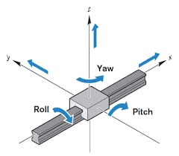

Roll: A roll moment is a force that attempts to cause a system to rotate about its X axis, from side-to-side. A good example of roll is an airplane banking.

If a linear guide was not firmly mounted to its base, a roll moment would cause it to rotate about its X axis, like this airplane banking.

Recirculating bearings with a “back-to-back,” or “O,” raceway arrangement have higher roll moment capacities than bearings with a “front-to-front,” or “X,” arrangement, due to the larger moment arm formed by the contact lines between the balls and the raceways.

Pitch: A pitch moment attempts to cause a system to rotate about its Y axis, from front to back. To envision pitch, think of the nose of an airplane pointing downward or upward.

Yaw occurs when a force attempts to cause a system to rotate about its Z axis. To visualize yaw, imagine a model airplane suspended on a string. If the wind blows just right, the airplane’s wings and nose will remain level (no rolling or pitching), but it will rotate around the string from which it’s suspended. This is yaw.

Both pitch and yaw moments put excess loads on the balls located at the ends of a linear bearing, a condition sometimes referred to as edge loading.

**Laws of robotics, Classification of robot:**

First Law

Edit

A robot may not injure a human being or, through inaction, allow a human being to come to harm.

Second Law

Edit

A robot must obey the orders given it by human beings except where such orders would conflict with the First Law.

Third Law

Edit

A robot must protect its own existence as long as such protection does not conflict with the First or Second Law.

Zeroth Law

Edit

A robot may not harm humanity, or, by inaction, allow humanity to come to harm.

**Based on physical configuration**

1. Cartesian configuration

2. Cylindrical configuration

3. Polar configuration

4. Joint-arm configuration

2) Depending on Robot Base

1. Fixed-

Robots used in manufacturing are examples of fixed robots. They can not move their base away from the work being done.

Fig. Example of Fixed robot

Fig. Example of Fixed robot

2. Mobile- Mobile bases are typically platforms with wheels or tracks attached.

mobileroboticarm

Fig. Example of mobile type robots

3) Based on control systems

1. Point-to-point (PTP) control robot

The PTP robot is capable of moving from one point to another point. The locations are recorded in the control memory. PTP robots do not control the path to get from one point to the next point.

Common applications include:

Component insertion

Spot welding

Hole drilling

Machine loading and unloading

Assembly operations

2. Continuous-path (CP) control robot

The CP robot is capable of performing movements along the controlled path. With CP from one control, the robot can stop at any specified point along the controlled path.

All the points along the path must be stored explicitly in the robot’s control memory. Applications Straight-line motion is the simplest example for this type of robot. Some continuous-path controlled robots also have the capability to follow a smooth curve path that has been defined by the programmer. In such cases the programmer manually moves the robot arm through the desired path and the controller unit stores a large number of individual point locations along the path in memory (teach-in).

Typical applications include:

Spray painting

Finishing

Gluing

Arc welding operations

3. Controlled-path robot

In controlled-path robots, the control equipment can generate paths of different geometry such as straight lines, circles, and interpolated curves with a high degree of accuracy. Good accuracy can be obtained at any point along the specified path.

Only the start and finish points and the path definition function must be stored in the robot’s control memory. It is important to mention that all controlled-path robots have a servo capability to correct their path.

Fig. Some modern application of robots

Fig. Some modern application of robots

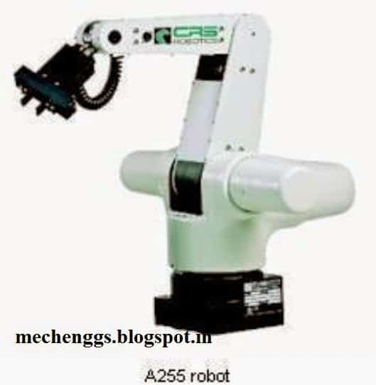

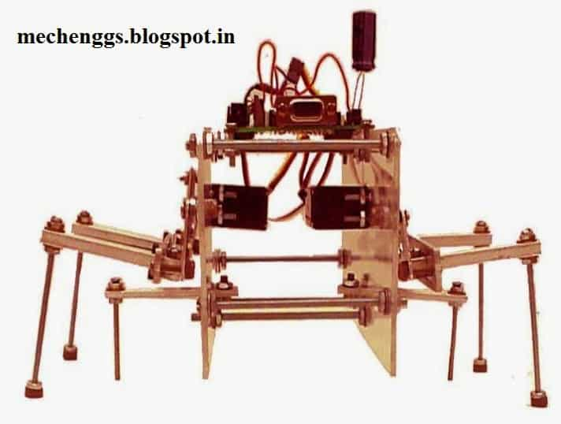

**Workspace, Accuracy, Resolution Repeatability of robot:**

**Resolution**:The resolution of a robot is a feature determined by the design of the control unit and is mainly dependent on the position feedback sensor. It is important to distinguish the programming resolution from the control resolution. The programming resolution is the smallest allowable position increment in robot programs and is referred to as the basic resolution unit (BRU). For IRB2000 ABB robot it is approximately 0,125 mm on linear axis. The control resolution is the smallest change in position that the feedback device can sense. For example, assume that an optical encoder which emits 1000 pulses per revolution of the shaft is directly attached to a rotary axis. This encoder will emit one pulse for each of 0,36° of angular displacement of the shaft. The unit 0,36° is the control resolution of this axis of motion. Angular increments smaller than 0,36° cannot be detected. Best performance is obtained when programming resolution is equal to control resolution. In this case both resolutions can be replaced with one term: the system resolution.

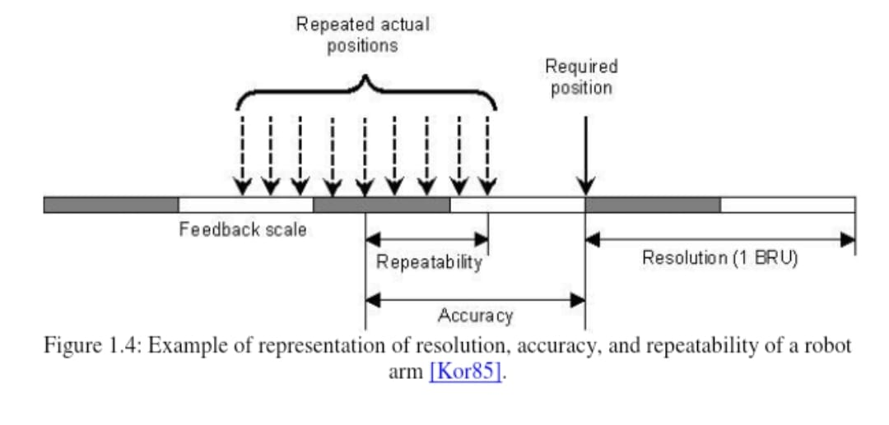

**Accuracy:**Accuracy refers to a robot's ability to position its wrist end at a desired target point within the work volume, and it is defined in terms of spatial resolution. At first accuracy depends on robot technology and how closely the control increments can be defined for each of the joint motions, excluding for the moment the mechanical inaccuracy which include the robot manufacture quality. Initially we define accuracy as one-half of the control resolution (Fig. 1.1), considering the worst case where the target point is directly between two control points. A more realistic considerations include mechanical inaccuracies with a statistical distribution

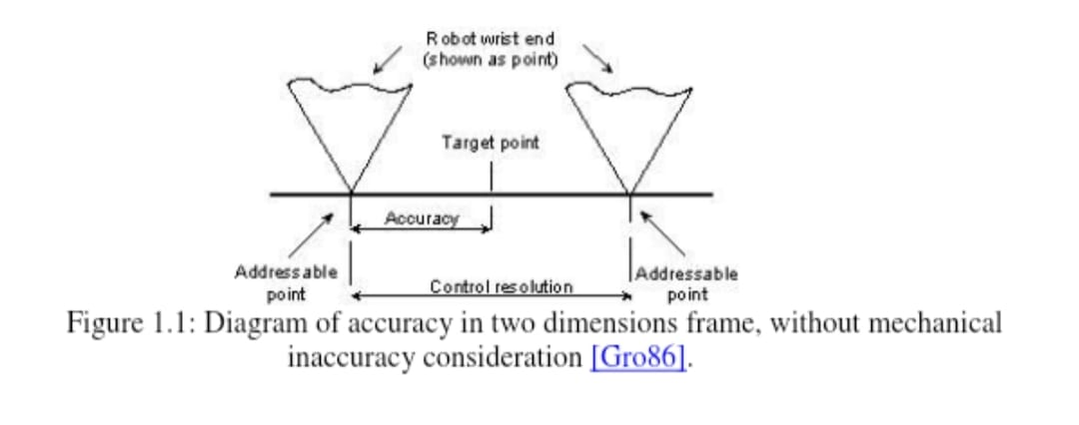

**Repeatability:** If a robot joint is instructed to move by the same angle from a certain point a number of times, all with equal environmental conditions, it will be found that the resultant motions lead to differing displacements (Fig. 1.4). Although a target is always missed by a large margin, if the same error is repeated, then we say that the repeatability is high and the accuracy is poor. Repeatability does not describe the error with respect to absolute coordinates. System repeatability is the positional deviation from the average of displacements. For example, +-0,2 mm indicates that any point might be as much as 0,2 mm beyond or short of the center of the repeatability pattern. Most robot manufacturers provide a numerical value for the repeatability rather than the accuracy of their robots. The reason is that the accuracy depends upon the particular load that the gripper carries. A heavier weight causes larger deflections of the robot links and larger load on the joints, which degrade the accuracy, while the repeatability value, however, is almost independent of the gripper load. The repeatability of robots will usually be better than the accuracy.

**Power transmission system: Rotary to rotary motion, Rotary to linear motion:**

**Rotary to linear motion:**

Rotation can be converted into linear motion via a screw-and-nut system assembled on the motor shaft. There are two main types of screw-and-nut systems: ball screw and lead screw.

A ball screw operates on rolling contact between the nut and a screw. The ball is recirculated along a helical groove. The rolling components keep friction low, while allowing high efficiency greater than 90 percent along with a high load capability.

**Rotary to Rotary:**

Rotary power transmission

Rotary power sources, e.g. motors are most common, and rotary power transmission is one of key issues for power

transmission. As motor output is usually of high speed, thus speed reduction with torque amplification case is generally

required for precision applications.

1) Gears

Gear is one of the frequently used elements for rotary transmission, and it is one of the rolling based elements, thus

giving very small friction coefficient, and the involute gear is using the involute curve formed by the intersection of tangent

line from the base circle and the line of involute angle, defined as inv φ= tan φ – φ

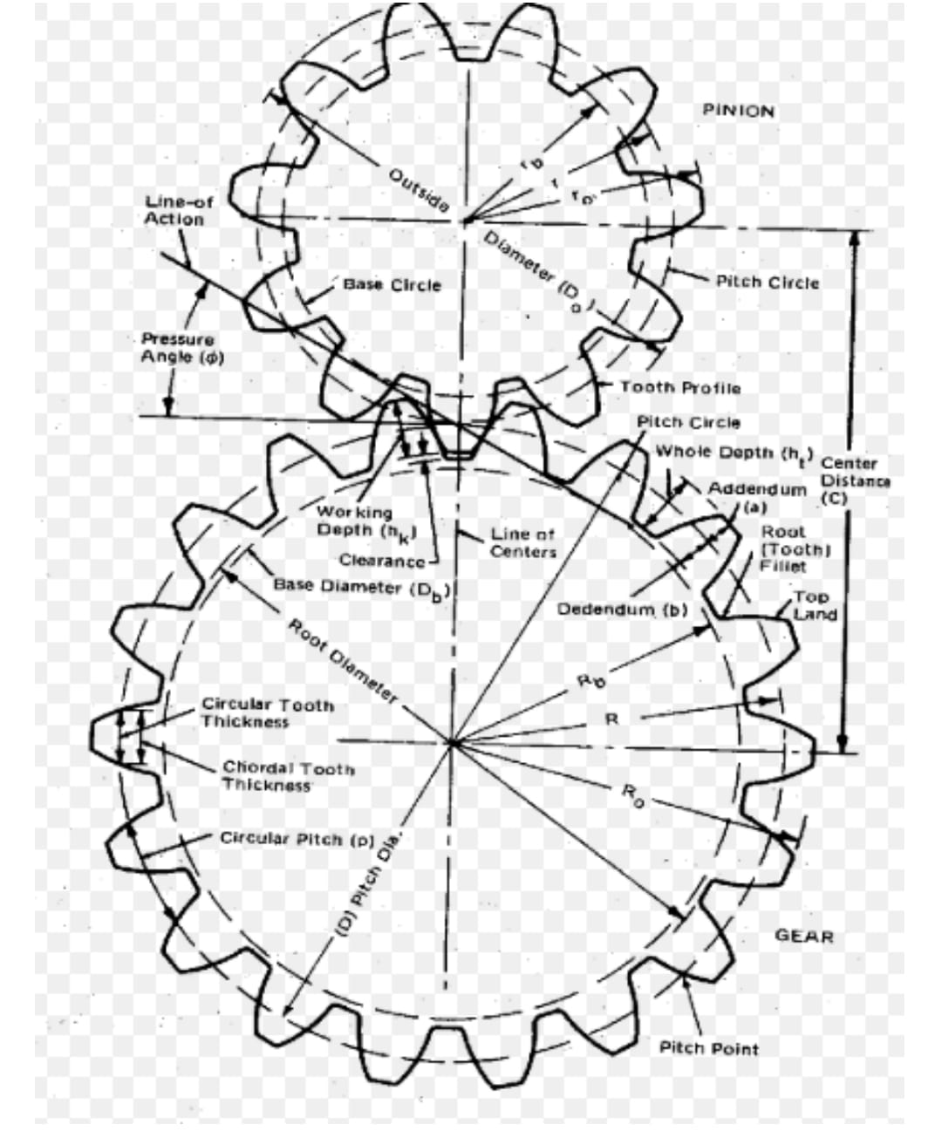

**Worm gear**

Worm gears have more complicated tooth geometry than spur gears, but they can give very high transmission ratio such as

Transmission ratio= R/p worm

where

R=radius of driven gear, pworm=pitch of the work gear.

Worm gears are frequently used in precision rotary indexing table and rotary axis in machine tools.

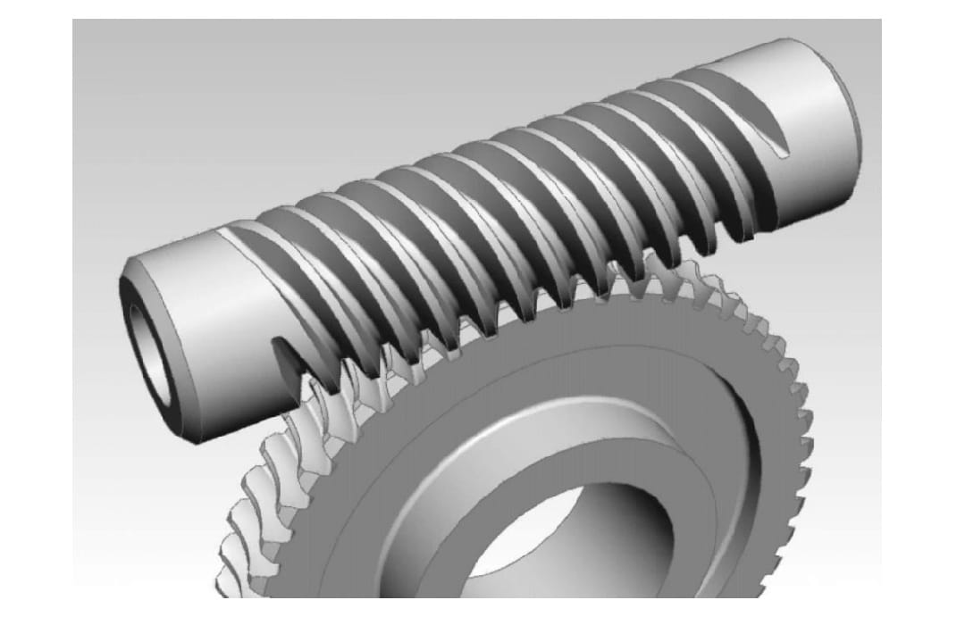

Planetary (epicyclic) speed reducer

:Consists of Ring gear(Outer gear), Sun gear(Centre gear), and planet pinions(Planetary pinions), in order to give higher load

and torque capability, by sharing the loads woth multi-planet pinons. The ring gear is rotating in one direction, the planetary pinions are rotating, then the centre gear is rotating in opposite direction. The transmission ratio is then

Transmission ratio=Rsun/(Rring-Rsun)

**Power transmission system, Harmonics drives, gear drives, belt drives:**

The power transmission system refers to the mechanism used to transfer power from a source to a driven load. There are several types of power transmission systems, including harmonics drives, gear drives, and belt drives. Let's take a closer look at each of them:

1. Harmonic Drives: Harmonic drives, also known as strain wave gears, are a type of gear system that uses an elastic component to achieve high gear reduction ratios with high precision. They consist of three main components: a wave generator, a flex spline, and a circular spline. The wave generator deforms the flex spline, causing a rolling motion between the teeth of the flex spline and the circular spline, resulting in a speed reduction. Harmonic drives are widely used in robotics, aerospace applications, and other industries where precise motion control is required.

2. Gear Drives: Gear drives are one of the most common types of power transmission systems. They use gears to transmit power and motion between two or more shafts. Gear drives can be classified into several types based on the arrangement of gears, such as spur gears, helical gears, bevel gears, and worm gears. Spur gears are the simplest type, with teeth parallel to the axis of rotation. Helical gears have teeth that are inclined at an angle, providing smoother and quieter operation. Bevel gears transmit power between intersecting shafts, while worm gears are used for large speed reduction ratios. Gear drives are used in a wide range of applications, including automotive transmissions, industrial machinery, and power generation systems.

3. Belt Drives: Belt drives use flexible belts, typically made of rubber or synthetic materials, to transmit power between two or more pulleys. They are widely used in various industries due to their flexibility, ease of installation, and ability to absorb shock and vibration. Belt drives can be classified into different types based on the arrangement of the pulleys, such as flat belts, V-belts, timing belts, and serpentine belts. Flat belts provide a smooth transfer of power but have lower load-carrying capacity compared to V-belts, which have a trapezoidal cross-section and are suitable for higher torque applications. Timing belts have teeth on the inner surface, allowing precise synchronization of shaft rotations. Serpentine belts are used in automotive engines to drive multiple accessories, such as the alternator, power steering pump, and air conditioning compressor. Belt drives are commonly found in applications such as conveyors, HVAC systems, and automotive powertrains.

Each of these power transmission systems has its own advantages and limitations, and the choice depends on factors such as the required speed reduction, torque capacity, precision, noise level, and the specific application requirements.

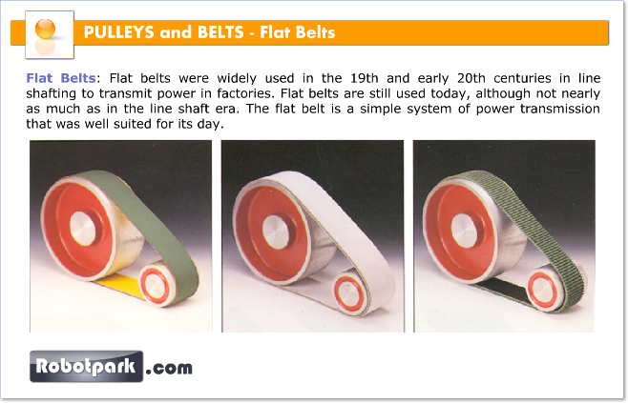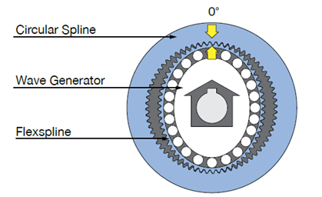

**Study of different type of links and joints used in robots:**

**Types of joints used in robots**

The Robot Joints is the important element in a robot which helps the links to travel in different kind of movements. There are five major types of joints such as:

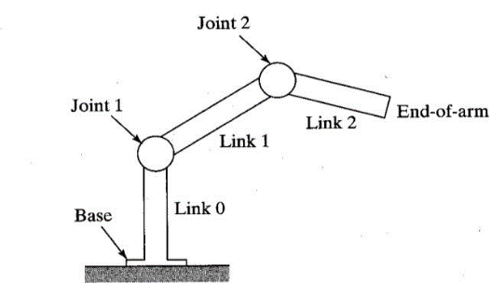

1.Rotational joint

2.Linear joint

3.Twisting joint

4.Orthogonal joint

5.Revolving joint

**Rotational Joint:**

Rotational joint can also be represented as R –Joint. This type will allow the joints to move in a rotary motion along the axis, which is vertical to the arm axes.

**Linear Joint:**

Linear joint can be indicated by the letter L –Joint. This type of joints can perform both translational and sliding movements.

These motions will be attained by several ways such as telescoping mechanism and piston. The two links should be in parallel axes for achieving the linear movement.

**Twisting Joint:**

Twisting joint will be referred as V –Joint. This joint makes twisting motion among the output and input link. During this process, the output link axis will be vertical to the rotational axis. The output link rotates in relation to the input link.

**Orthogonal Joint:**

The O –joint is a symbol that is denoted for the orthogonal joint. This joint is somewhat similar to the linear joint. The only difference is that the output and input links will be moving at the right angles.

**Revolving Joint:**

Revolving joint is generally known as V –Joint. Here, the output link axis is perpendicular to the rotational axis, and the input link is parallel to the rotational axes. As like twisting joint, the output link spins about the input link.