**Unit-2**

1. **Robot End effectors**:

* A robot end effector is a device or tool that is attached to the end of a robot arm or manipulator.
* Its primary purpose is to perform a specific task or function, such as grasping, manipulating, or assembling objects.
* End effectors can take many different forms depending on the task they are designed to perform.
* Some examples of common end effectors include grippers, suction cups, welding torches, and cutting tools. End effectors can be either passive or active.
* Passive end effectors do not have any built-in functionality or motorized components, while active end effectors include motors or other mechanisms that allow them to perform more complex tasks.
* The choice of end effectors depends on the specific application and the type of task the robot is intended to perform. For example, a robot designed to perform welding tasks may be equipped with a welding torch, while a robot designed for material handling tasks may be equipped with a gripper.
* Overall, end effectors are an essential component of robotic systems and play a critical role in the performance and versatility of the robot.
* End effectors may consist of a gripper or a tool. When referring to robotic pretension there are four general categories of robot gripper

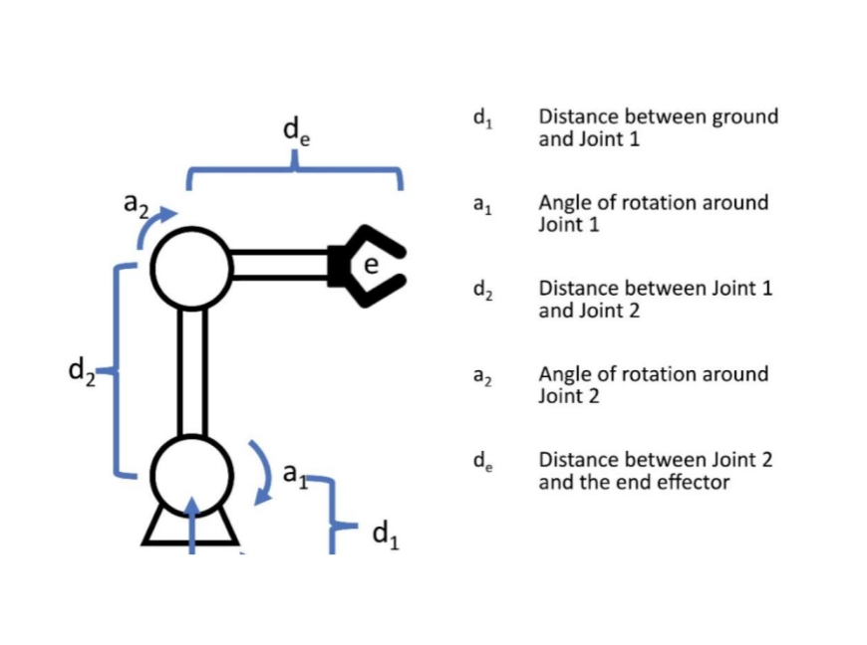

**2. Types of End effectors, Mechanical gripper:**

End effectors are the device or tool at the end of a robotic arm or manipulator that interacts with the environment to perform a task. There are several types of end effectors, including:

* Grippers: Grippers are the most common type of end effector, and they are used to grip and hold objects. They come in a variety of designs, such as two-finger, three-finger, and vacuum grippers.
* Welding guns: Welding guns are used in robotic welding systems and are designed to hold and manipulate welding tools to join two materials.
* Suction cups: Suction cups are used to grip and lift objects with smooth surfaces, such as glass or plastic sheets.
* Cutting tools: Cutting tools, such as saws or plasma cutters, are used in robotic cutting systems to cut through materials.
* Screwdrivers: Screwdrivers are used to install and remove screws in manufacturing processes.
* Paint sprayers: Paint sprayers are used in robotic painting systems to apply paint to objects.
* Sensors: Sensors can be used as end effectors to measure physical properties, such as temperature or pressure, of objects. The choice of end effectors depends on the specific task the robot needs to perform and the properties of the objects being manipulated.

**Mechanical gripper:**

Mechanical grippers are one type of end effector commonly used in robotics and automation systems to pick up and manipulate objects. A mechanical gripper typically consists of two or more hinged or parallel jaws that can open and close to grip an object securely. There are several types of mechanical grippers based on their mechanism of action, including

* Parallel Gripper This type of gripper has two parallel jaws that move towards or away from each other to grip or release an object. Parallel grippers are commonly used in pick-and-place applications.
* Angular Gripper: Angular grippers have jaws that move in an angular or curved path to grip an object from the side. They are commonly used for handling objects that are difficult to grip with parallel jaws.
* 3-Finger Gripper: This type of gripper has three fingers that move towards the center to grip an object. 3-finger grippers are commonly used in applications that require a secure grip and high dexterity.
* 2-Finger Gripper: 2-finger grippers have two fingers that move towards each other to grip an object. They are commonly used in pick-and-place applications and assembly operations.
* Pneumatic Gripper: Pneumatic grippers use compressed air to actuate the jaws and grip an object. They are commonly used in industrial automation systems due to their speed and reliability.
* Electric Gripper: Electric grippers use an electric motor to actuate the jaws and grip an object. They are commonly used in applications that require precise control and high accuracy.

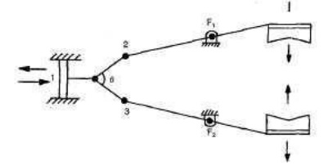

**3. Types of gripper mechanism:**

A gripper mechanism is a device used to grasp, hold, and release objects. There are several types of gripper mechanisms that are commonly used in various applications, including:

* Parallel Gripper: The parallel gripper is the most common type of gripper mechanism used in industrial automation. It consists of two jaws that move in parallel to each other to grip the object.
* Angular Gripper: Angular grippers are used when the objects being gripped are not parallel to each other. They have a curved jaw that can adjust to the object’s shape.
* Vacuum Gripper: A vacuum gripper uses suction to hold onto objects, typically used for picking up flat, smooth objects such as glass sheets, printed circuit boards, or other flat items.
* Magnetic Gripper: A magnetic gripper uses magnetic force to hold onto ferromagnetic materials, such as steel, iron, and nickel.
* Pneumatic Gripper: A pneumatic gripper uses compressed air to open and close the jaws, providing a powerful grip on the object.
* Hydraulic Gripper: Hydraulic grippers use pressurized hydraulic fluid to provide a strong and precise grip, making them ideal for heavy-duty applications.
* Servo Gripper: Servo grippers use a servo motor to precisely control the opening and closing of the jaws, providing high precision and accuracy in gripping and releasing objects. Each type of gripper mechanism has its unique features and advantages, making them suitable for various applications.

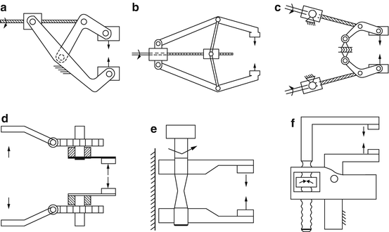

**4. Gripper force analysis – Theory:**

* Gripper force analysis is a method of analyzing the force required to grip or hold an object securely using a gripper mechanism. The theory behind gripper force analysis involves understanding the properties of the gripper mechanism and the object being gripped, as well as the environment in which the gripping is taking place.
* The force required to grip an object depends on several factors, including the weight and size of the object, the surface texture of the object, and the friction between the gripper and the object. The gripper mechanism itself can also play a significant role in the force required to grip an object, with factors such as the shape of the gripper fingers, the material they are made from, and the actuation method all affecting the gripping force.
* To analyze the gripper force, the first step is to determine the weight and size of the object being gripped. The gripper mechanism must then be designed to provide enough force to securely hold the object in place. This can be achieved through a variety of means, including increasing the size of the gripper fingers or using a more powerful actuation mechanism.
* Friction is another important factor in gripper force analysis. The coefficient of friction between the gripper and the object being held can significantly impact the force required to grip the object. A low-friction surface will require less gripping force, while a high-friction surface will require more force.
* In addition to friction, the surface texture of the object being gripped can also affect the gripping force. A rough surface will provide more grip than a smooth surface, and a soft or pliable object may require a different gripping mechanism altogether.
* Ultimately, the goal of gripper force analysis is to ensure that the gripper mechanism is capable of providing enough force to hold the object securely in place without damaging it. This requires careful consideration of the properties of both the gripper mechanism and the object being gripped, as well as the environment in which the gripping is taking place.

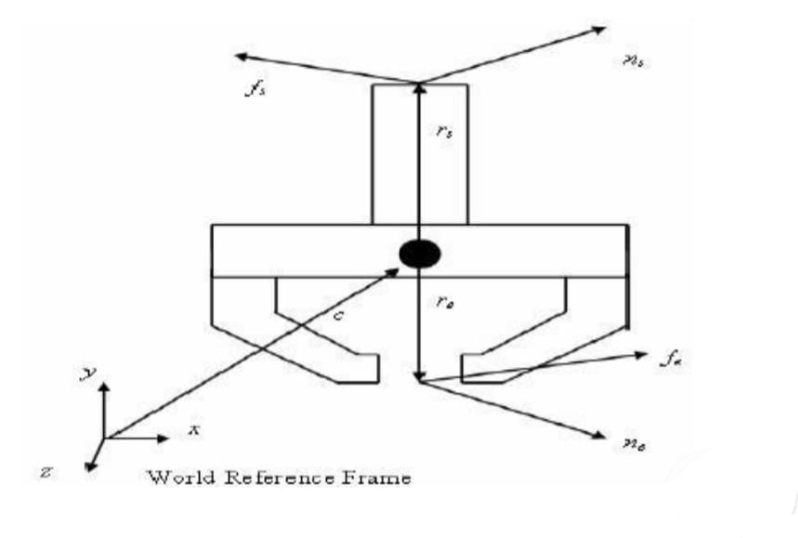

**5. Other types of gripper, Special purpose grippers:**

There are many types of special purpose grippers, each designed for specific tasks and applications. However, the basic principle of gripper force analysis remains the same. To analyze the gripper force for a special purpose gripper, you will need to consider the following parameters:

* Grip force: The force required to grip the object securely. This is typically determined by the weight and size of the object, as well as the friction between the gripper and the object.
* Actuation force: The force required to activate the gripper mechanism. This may involve pneumatic, hydraulic, or electric actuators, and will depend on the design of the gripper.
* Closing speed: The speed at which the gripper closes around the object. This can affect the grip force, as well as the overall efficiency of the gripping process.
* Gripper opening width: The distance between the gripper fingers when they are fully open. This will determine the maximum size of the objects that can be gripped.
* Material strength: The strength and durability of the materials used in the gripper. This will affect the maximum force that the gripper can exert without breaking or deforming

By analyzing these parameters, you can determine the optimal grip force for a given object and gripper design, as well as the maximum weight and size of objects that the gripper can handle. You can also evaluate the efficiency and durability of the gripper under various operating conditions.

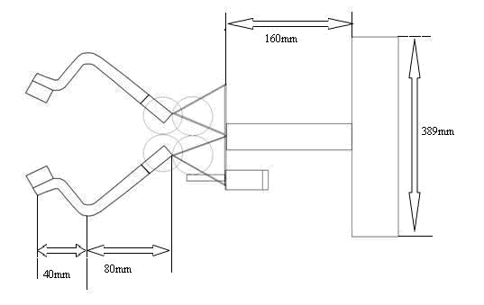

**6. Verification of transformation (Position and orientation) with Respect to gripper and world Coordinate system:**

* To verify the transformation of position and orientation with respect to the gripper and the world coordinate system, you would need to perform a calibration or alignment process.
* Here are some general steps you can follow:
* Choose a reference point in the world coordinate system, such as the center of a calibration board or a fixed object with known position and orientation.
* Move the gripper to the reference point and record its position and orientation using a measurement tool such as a laser tracker, photogrammetry system, or a coordinate measuring machine.
* Use software to compute the transformation matrix between the gripper coordinate system and the world coordinate system based on the recorded position and orientation data.
* Repeat this process for several other reference points in different locations and orientations to validate the transformation matrix.
* Use the validated transformation matrix to control the motion of the robot arm and perform various tasks.
* Periodically check and recalibrate the transformation matrix to ensure accurate and reliable operation.
* Note that the specific details of the calibration or alignment process may vary depending on the type of robotic arm and measurement tool you are using. It’s also important to follow the manufacturer’s instructions and guidelines to ensure safe and proper use of the equipment.

**7. Determination of maximum and Minimum position of links:**

* To determine the maximum and minimum positions of links in a mechanism, you need to consider the kinematic constraints of the system.
* Assuming that the links are rigid and have fixed lengths, the maximum and minimum positions of the links will be determined by the joint limits and the geometric constraints of the system.
* For example, in a simple four-bar linkage, the maximum and minimum positions of the links can be determined by analyzing the kinematics of the system.
* The four-bar linkage consists of four rigid links connected by four revolute joints.
* The maximum and minimum positions of the links will depend on the angle between the input and output links, as well as the lengths of the four links.
* By analyzing the kinematics of the system, you can determine the range of motion of each link, which will correspond to the maximum and minimum positions of the links.
* In more complex mechanisms, the determination of maximum and minimum positions of links can become more complicated, requiring a more detailed analysis of the kinematics and constraints of the system.
* However, the basic principle remains the same: analyze the kinematic constraints of the system to determine the maximum and minimum positions of the links.

**8 .CBS1 – “Vacuum Gripper”:**

* The CBS1 Vacuum Gripper is a type of end effector used in industrial automation to handle and manipulate objects.
* It utilizes a vacuum to create a suction force, which allows it to securely grip and lift objects without causing any damage or leaving any marks.
* The vacuum gripper is designed to work with a variety of different objects, such as boxes, bags, and other types of packaging materials.
* The CBS1 Vacuum Gripper Is typically used in conjunction with a robotic arm or other type of automation system.
* It can be programmed to pick up objects from a conveyor belt or other type of input and then move them to a specific location for further processing or packaging.
* One of the key advantages of the CBS1 Vacuum Gripper is its versatility. It can be used to handle objects of various shapes and sizes, and it can be easily customized to meet the specific needs of different applications. Additionally, the vacuum gripper is easy to maintain and operate, making it a popular choice for many industrial automation applications.
* Overall, the CBS1 Vacuum Gripper is a reliable and efficient tool for handling objects in industrial settings.
* Its ability to securely grip and lift objects without causing damage makes it an ideal choice for a wide range of applications.

