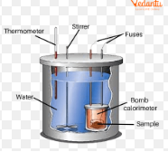A **bomb calorimeter** is a device used to measure the **calorific value** of a fuel or other substance. It works by burning the sample in a sealed chamber (the "bomb") and measuring the heat released to the surrounding water jacket.

bomb calorimeter An apparatus primarily used for measuring heats of combustion. The reaction takes place in a closed space known as the calorimeter proper, in controlled thermal contact with its surroundings, the jacket, at constant temperature.The principle of calorimetry indicates the law of conservation energy, i.e. the total heat lost by the hot body is equal to the total heat gained by the cold body.

Calorimeters are used to measure the volume and heat produced during a certain time interval. The flow is passed through a tank partly filled with water whose thermal capacity and weight are known before the beginning of the experiment.