DENSITY OF STATES

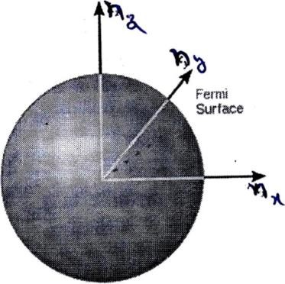

The number of states with energy less than *Ef* is equal to the number of states that lie within a sphere of radius *nf* in a region of K–space where *nx* , *ny* and *nz* are positive.

 *N*  2 1  4 *n*3

##### 8 3 *f*

 *N*  2  1  4 *n*3  3*N* ⇒

*nf*  (  )3

3*N* 1

8 3 *f* 

So the Fermi energy

h2 2 *n*2 h2 2 3*N* 2

*E*  *f* = ( )3

*f* 2*ma*2 2*ma*2 

4 2

2 3*N* 2 h2  ~~3~~ (3*N* ) 3 h2 3*N* 2 2 h2 3*N* 2 2

2

##### *E*  h  ( )3   ( )3  ( )3

*f* 2*m a*2

❐ 2*m* 2

(*a* )

3 3

2*m a*3

2*m V*

2 2*m V* 2

 *N* 3  ( )3 *E*

h2 3 2 *f*

2*m* 3 *V* 3

⇒ *N*  ( )2 ( )*E* 2

h2 3 2 *f*

*dN* 3 2*m* 3 *V* 1

Therefore density of states: *D*(*E*)   ( )2 ( )*E* 2

*dE* 2 h2 3 2 *f*

*V* 2*m*3 1

*D*(*E*)  ( )2 *E* 2

2 2 h2 *f*

Therefore the total number of energy states per unit volume per unit energy range

*D*(*E*) 1 2*m* 3 1 1 (2*m*)23

1

*Z* (*E*)   ( )2 *E* 2  8 3*E* 2

*V* 2 2 h2 *f* 2 2 *h*3 *f*

4 3 1

*Z* (*E*)  (2*m*)2 *E* 2

*h*3 *f*

Therefore the number of energy states in the energy interval E and *E*  *dE* are

*Z* (*E*)*dE*  (2*m*) *E dE*

4

3 1

2

2

*h*3

*f*

# Important questions

1. a. Explain the salient features of classical free electron theory
   1. On the basis of classical free electron theory, derive the expressions for i) drift Velocity, ii) current density iii) mobility?
   2. What are drawbacks of classical free electron theory of materials?
2. a. Explain Fermi-Dirac distribution for electrons in a metal. Discuss its variation with temperature?
   1. Explain the terms ‘Mean free path’ ‘Relaxation time’ and ‘Drift velocity’ of an electron in a metal?
   2. Discuss the origin of electrical resistance in metals?
3. a. Derive the expression for electrical conductivity on the basis of quantum free electron theory?
   1. Explain i) Fermi energy?
   2. Evaluate the Fermi function for an energy KT above Fermi energy?